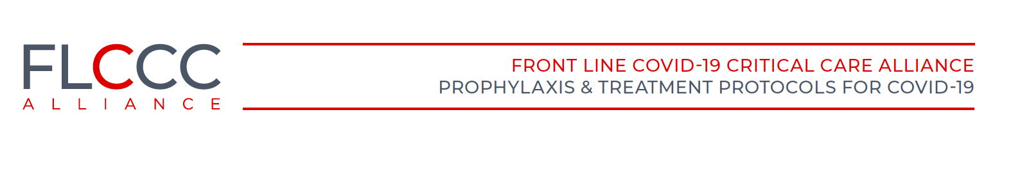

Summary Review of the Emerging Evidence Demonstrating the Efficacy of Ivermectin in the Prophylaxis and Treatment of COVID-19

Pierre Kory, MD1*, G. Umberto Meduri, MD2†, Jose Iglesias, DO3, Joseph Varon, MD4 , Keith
Berkowitz, MD5 , Howard Kornfeld, MD6 , Eivind Vinjevoll, MD7 , Scott Mitchell, MBChB8 , Fred Wagshul, MD9, Paul E. Marik, MD10

1 Front-Line Covid-19 Critical Care Alliance.
2 Memphis VA Medical Center - Univ. of Tennessee Health Science Center, Memphis, TN.
3 Hackensack School of Medicine, Seton Hall, NJ.
4 University of Texas Health Science Center, Houston, TX.
5 Center for Balanced Health, New York
6 Recovery Without Walls
7 Volda Hospital, Volda, Norway
8 Princess Elizabeth Hospital, Guernsey, UK
9 Lung Center of America, Dayton, Ohio
10 Eastern Virginia Medical School

Supporting a role for ivermectin in decreasing transmission rates can be found from South American countries where, in retrospect, large “natural experiments” appear to have occurred. For instance, beginning as early as May, various regional health ministries and governmental authorities within Peru, Brazil, and Paraguay initiated “ivermectin distribution” campaigns to their citizen populations (Chamie, 2020). In one such example from Brazil, the cities of Itajai, Macapa, and Natal distributed massive amounts of ivermectin doses to the city’s population, where, in the case of Natal, 1 million doses were distributed.7 The data in Table 1 below was obtained from the official Brazilian government site and the national press consortium and show large decreases in case counts in the three cities soon after distribution began compared to their neighboring cities without such campaigns.
Table 1. Comparison of case count decreases among Brazilian cities with and without ivermectin.

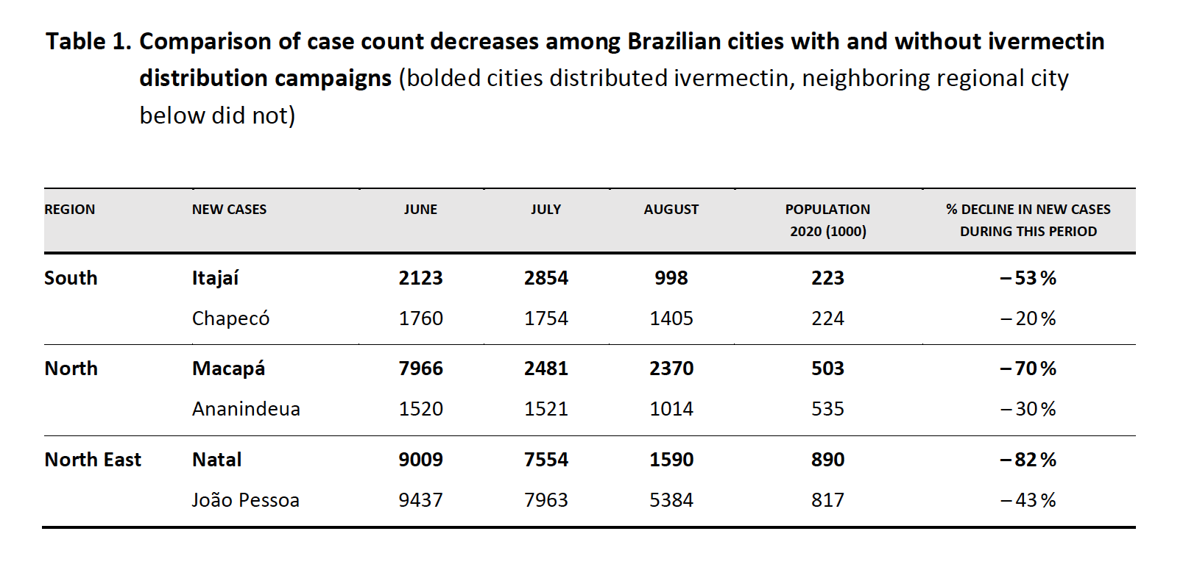

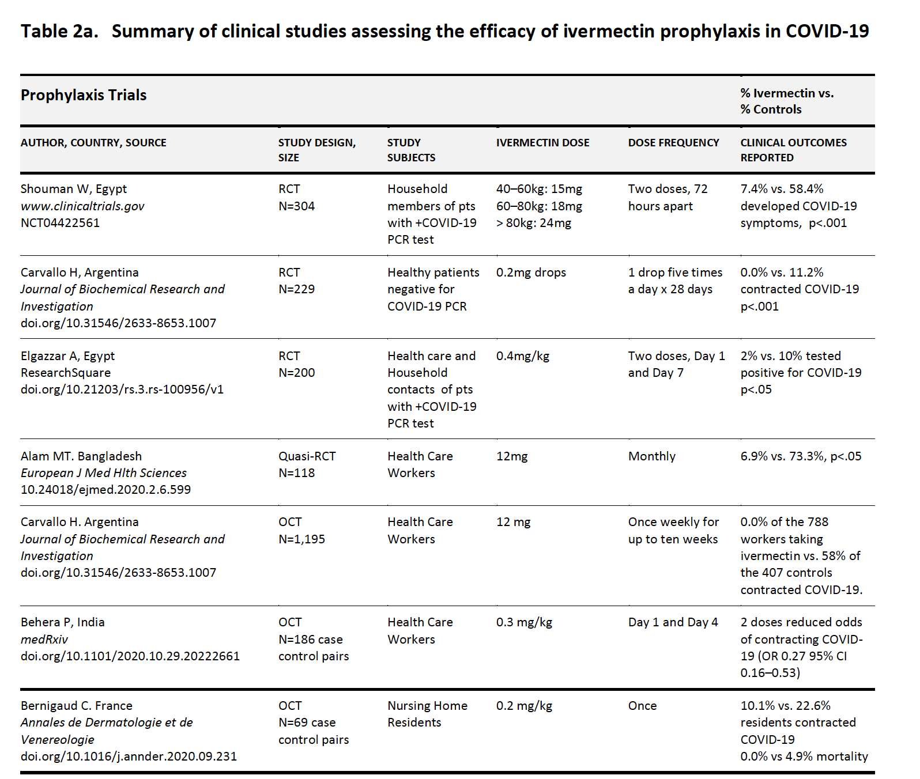

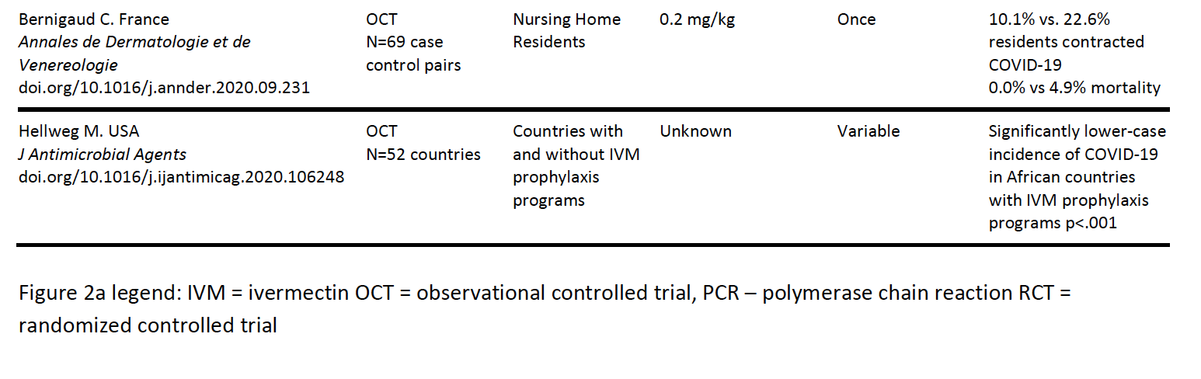

Clinical studies on the efficacy of ivermectin in treating mildly ill outpatients

Currently, six studies which include a total of over 3,000 patients with mild outpatient illness have been completed, a set comprised of 5 RCT’s and four case series (Cadegiani et al., 2020;Carvallo et al., 2020a;Chaccour et al., 2020;Chowdhury et al., 2020;Espitia-Hernandez et al., 2020;Gorial et al., 2020;Hashim et al., 2020;Khan et al., 2020;Mahmud, 2020;Podder et al., 2020).

The largest RCT by Mahmud et al. was conducted in Dhaka, Bangladesh and targeted 400 patients with 363 patients completing the study (Mahmud, 2020). In this study, as in many other of the clinical studies to be reviewed, either a tetracycline (doxycycline) or macrolide antibiotic (azithromycin) was included as part of the treatment. The importance of including antibiotics such as doxycycline or azithromycin is unclear, however, both tetracycline and macrolide antibiotics have recognized anti-inflammatory, immunomodulatory, and even antiviral effects (58-61). Although the posted data from this study does not specify the amount of mildly ill outpatients vs. hospitalized patients treated, important clinical outcomes were profoundly impacted, with increased rates of early improvement (60.7% vs. 44.4% p<.03) and decreased rates of clinical deterioration (8.7% vs 17.8%, p<.013). Given that mildly ill outpatients mainly comprised the study cohort, only two deaths were observed (both in the control group).

Another RCT by Hashim et al. in Baghdad, Iraq included 140 patients equally divided; the control group received standard care, the treated group included a combination of both outpatient and hospitalized patients (Hashim et al., 2020). In the 96 patients with mild-to-moderate outpatient illness, they treated 48 patients with a combination of ivermectin/doxycycline and standard of care and compared outcomes to the 48 patients treated with standard of care alone. The standard of care in this trial included many elements of the MATH+ protocol, such as dexamethasone 6mg/day or methylprednisolone 40mg twice per day if needed, Vitamin C 1000mg twice/day, Zinc 75–
125mg/day, Vitamin D3 5000 IU/day, azithromycin 250mg/day for 5 days, and acetaminophen 500mg as needed. Although no patients in either group progressed or died, the time to recovery was significantly shorter in the ivermectin treated group (6.3 days vs 13.7 days, p<.0001).

Cadegiani in Brazil performed a prospective trial comparing patients treated with either ivermectin, hydroxychloroquine, or nitazoxanide where they describe the selection of patients treated with each agent as having been done in a quasi-randomized manner (Cadegiani et al., 2020). They found that in the 538 ivermectin treated patients compared to non-ivermectin treatment arms, 0% vs 19.7% required hospitalization, (p<.0001), 0% vs. 6.6% required mechanical ventilation (p<.0001), and 0% vs 1.4% died (NS).
A small RCT from Spain by Chaccour was recently posted where they randomized 24 patients to ivermectin vs placebo and although they found no difference in PCR positivity at day 7, although they did find statistically significant decreases in viral loads, patient days of anosmia (76 vs 158, p<.05), and patient days with cough (68 vs 98, p<.05) (Chaccour et al., 2020).
Another RCT of ivermectin treatment in 116 outpatients was performed by Chowdhury et al. in Bangladesh where they compared a group of 60 patients treated with the combination of ivermectin/doxycycline to a group of 60 patients treated with hydroxychloroquine/doxycycline with a primary outcome of time to negative PCR (Chowdhury et al., 2020). Although they found no difference in this outcome, in the treatment group, the time to symptomatic recovery approached statistical significance (5.9 days vs. 7.0 days, p=.07). In another smaller RCT of 62 patients by Podder et al., they also found a shorter time to symptomatic recovery that approached statistical significance (10.1 days vs 11.5 days, p>.05, 95% CI, 0.86 – 3.67) (Podder et al., 2020).
A medical group in the Dominican Republic reported a case series of 2,688 consecutive symptomatic outpatients seeking treatment in the emergency room, the majority of whom were diagnosed using a clinical algorithm. The patients were treated with high dose ivermectin of 0.4mg/kg for one dose along with five days of azithromycin. Only 16 of the 2,688 patients (0.59%) required subsequent hospitalization with one death recorded (Morgenstern et al., 2020).

In another case series of 100 patients in Bangladesh, all treated with a combination of 0.2mg/kg ivermectin and doxycycline, they found that no patient required hospitalization nor died, and all patients’ symptoms improved within 72 hours (Robin et al., 2020).
A case series from Argentina reported on a combination protocol which used ivermectin, aspirin, dexamethasone and enoxaparin. In the 135 mild illness patients, all survived (Carvallo et al., 2020a). Similarly, a case series from Mexico of 28 consecutively treated patients with ivermectin, all were reported to have recovered with an average time to full recovery of only 3.6 days (Espitia-Hernandez et al., 2020).
A detailed summary of each trial which comprised the previously reviewed clinical evidence base of outpatients treated with ivermectin can be found in Table 2b below.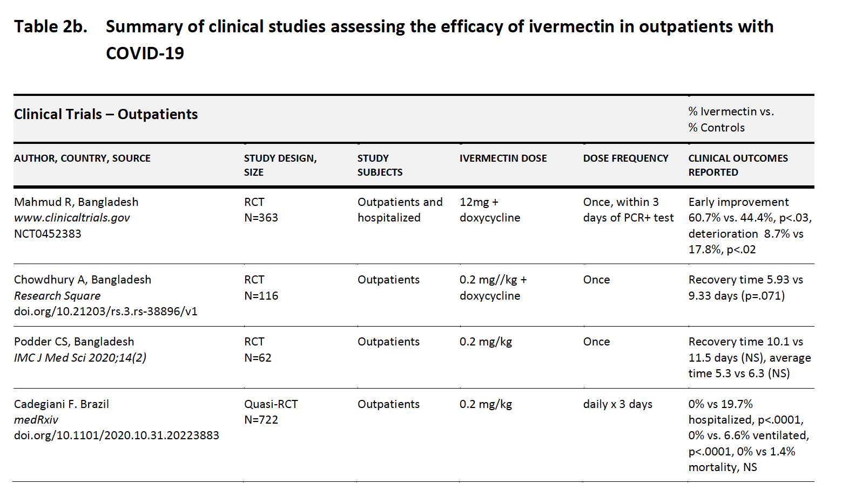
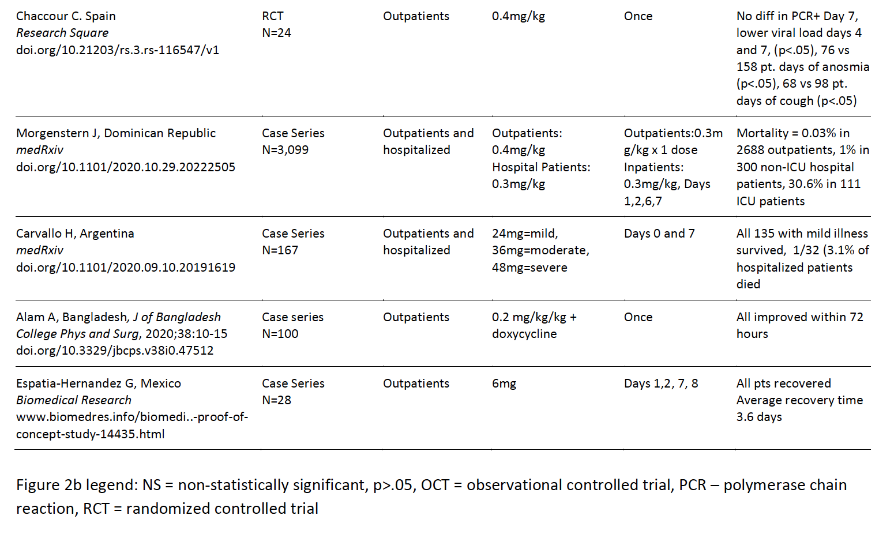
Summary of the clinical evidence base for ivermectin against COVID-19

The below meta-analysis includes the mortality data from the OCTs and RCTs separately (Figure 3). The consistent and reproducible signals leading to an overall statistically significant mortality benefit from within both study designs is remarkable, especially given that in several of the studies treatment was initiated late in the disease course.
A categorical summary of the statistically significant results found from the 24 controlled trials included in Table 2 above are as follows:
